2019 Semester 1, Year 11 Unit 1 Economics Examination

Section 1 – Multiple Choice
1 | D | 13 | A
2 | B | 14 | D
3 | C | 15 | B
4 | A | 16 | B
5 | D | 17 | C
6 | A | 18 | A
7 | A | 19 | C
8 | C | 20 | A
9 | B | 21 | B
10 | D | 22 | A
11 | A | 23 | D
12 | B | 24 | A

Section 2 – Data Interpretation
Question 25 (a) (2m)
- 6 x 4m = 24m (1m)
- 2.5 x 4m = 10m (1m)

Question 25 (b) (4m)
- Diagram (accurate – second mark is the shift of Demand C) (2m)
- Impact on equilibrium price (1m)
- Impact on equilibrium qty (1m)
- DD factor (taste and preference for 4th mark.) (1m)
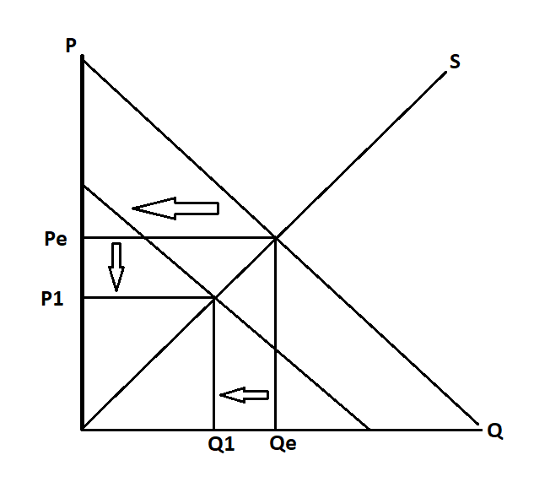
P reduced, Q reduced

Question 25 (c) (6m)
- At least 3 Supply factors to be identified
- Identify factor (1m) x 3
- Explain factor within context (1m) x 3
Eg.
- Cost of production
- Technology
- Government policy
- Expectations (market)
- Change in size of market
Number of growers, weather, technology, other factors of production costs

Question 26 (a) (2m)
- Define opportunity cost - next best alternative forgone (1m)
- Eg. Govt Expenditure on – Hospitals, Schools, Roads, etc. (1m)
Question 26 (b) (6m)
- Diagram (accurate and sufficiently referred to) (2m)
- Impact on efficiency
- Highlight change in CS and PS (Total Surplus) (1m)
- Deadweight Loss highlights inefficiency (1m)
- Impact on equity
- lower prices - greater affordability (1m)
- more lower income groups have access – improves horizontal equity (1m)

Question 26 (c) (4m)
- Identify Policy x 2 (1m) x 2
- Policies – Subsidies, Public housing, progressive Taxes (redistributive), Improved access to education, price floors, etc
- Explanation: (1m) x 2
Explanation must link to improvement in welfare of lower SES grps
Market based measures should highlight link to impact on market (P & Q)

E.g.
- Subsidies (1m)
Explanation (1m)
  - Lowers cost of production; reduces equilibrium price rendering good/service more affordable. Lower income groups enjoy greater access due to improved affordability.
- Build public housing (1m)
Explanation (1m)
  - Increase in supply of public housing, lowers price of housing due to increased supply reduces rental rates due to greater availability. Improves affordability.
Note: If Price ceiling is included in the response only a 1-mark maximum is awarded. This is due to repetition with Qn. 26 (b)

Question 27 (a) (2m)
Atmosphere – Explain in terms of rivalry and excludability
- Rival in consumption – use degrades breathable air (1m)
- Non-excludable – costly to exclude users in obtaining benefits from its use (1m)

Question 27 (b) (2m)
Explanation - Explain in terms of rivalry and excludability
- Non- excludability leads to overuse and because usage is rivalrous it leads to degradation of common property resource for which no appropriate compensation is paid (1m)
- 3rd party effect -> Poor atmosphere -> asthma, lung disease, etc. (1m)

Question 27 (c) (4m)
- Diagram (accurate and sufficiently referred to) (1m)
- Marginal External Cost (MEC) not taken into account (1m)
- Overproduction highlighted – Overallocation of resources (1m)
- Deadweight loss (misallocation of resources) linked to inefficiency (1m)
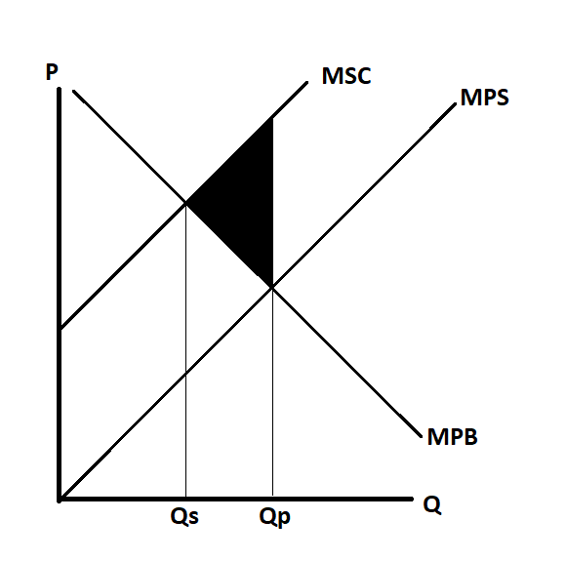
Question 27 (d) (4m)
- Identify policy x 2 (1m) x 2
Policy options - Pigouvian tax, Regulation, Education, Advertising, etc.
- Explanation: (1m) x 2
Market-based measures (like taxes) should highlight internalisation of cost
Must link to reduction of externality (effect on 3rd party) – If not linked for both policy options a maximum of 1 mark deducted.

